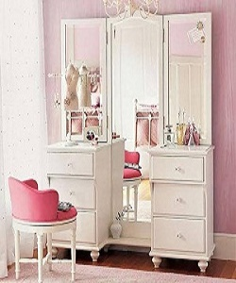

Modern Dressing table

$166.66

Availability: In stock

**Description:**

Modern white dressing table with 3 mirrors, 6 drawers and one small modern pink chair.  The finish and contemporary design are adaptable for any decor style. It is perfect to prepare yourself for a day of work or important date at night. One storage drawer provide sample hidden storage space for small items. Available with us at highly affordable market prices, these Dressing table are available in customers stated specifications.